Twitter application

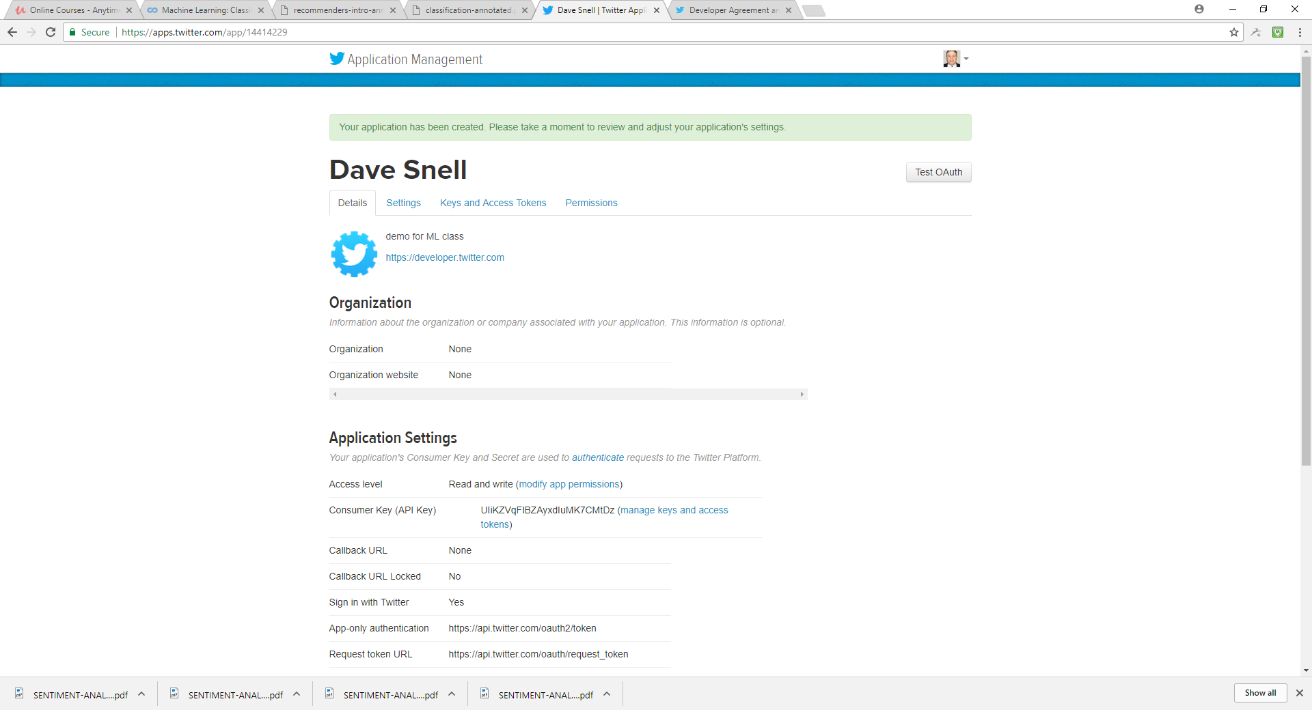

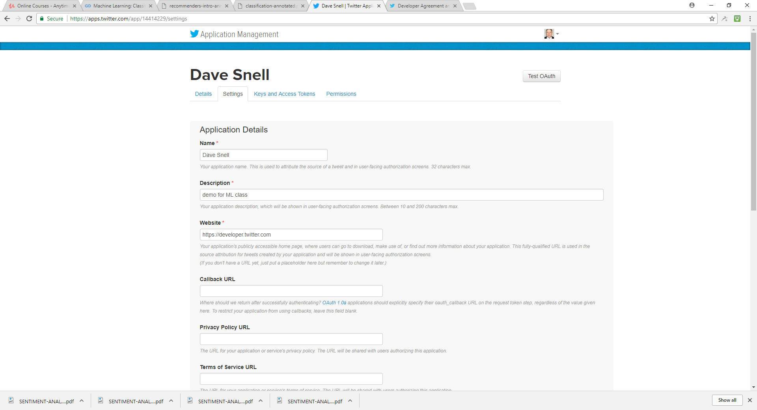

First, create a twitter account (or login to your existing account)

Go to <https://apps.Twitter.com>

Click on the Create New App button

Fill out the form. If you do not already have a website, you can use [https://developer.twitter.com](https://developer.twitter.com/)

Go to the next page, click on the Keys and Access Tokens tab, and copy your API key and API secret. Scroll down and click on Create my access token, and copy your Access token, and Access token secret.

Consumer Key (API Key)UIiKZVqFlBZAyxdIuMK7CMtDz

Consumer Secret (API Secret)loiPCSlZVvgzrFFJ5ZaA0DOzMeaQ8dvJ4Qqg5i80wUSCHXRKKb

Access LevelRead and write ([modify app permissions](https://apps.twitter.com/app/14414229/permissions))

Ownersnell_dave

Owner ID550502130

Click on Create my access token

Your Access Token

*This access token can be used to make API requests on your own account's behalf. Do not share your access token secret with anyone.*

Access Token550502130-Au3LZrUoDcLNG4kAUu4swgKAAGn7Ap9FBSelaAn6

Access Token SecretEP6n8nP4FSoEj2gu47mGPrB43nVRxn6J8vFWeAUBsHS8S

Access LevelRead and write

Ownersnell_dave

Owner ID550502130

conda update --all

conda install requests